Purchase Management

To create vendor

Purchase -> Order -> Vendor -> Create
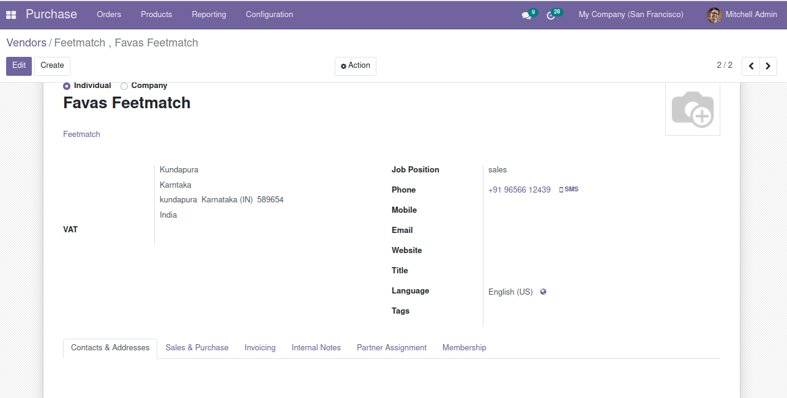

Request for Quotation

To create RAQ

Purchase -> Orders -> Request for Quotation -> create

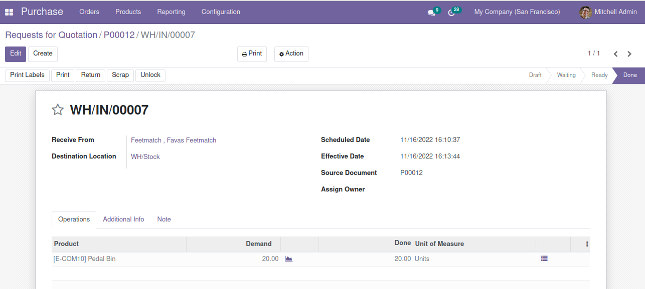

Purchase Orders

To create purchase order

Purchase -> Orders -> Product Order -> Create

